**Step by Step Details for the project overview**

This document elaborates the steps that I have done in Power BI for Dashboard creation

* **Step1**: Loading all the files 1) Categories 2) Geography 3) Product, this table is in .csv format so it can be loaded directly into Power BI or through a database connection if the table is in databases like MySQL, Microsoft SQL Server, Oracle etc. 4) Sales, this has 4 years data in different Excel files so loaded the entire folder (C:\Users\ajodh\Downloads\PowerBI Project\Sales) so that once a new year data is generated it can be loaded in Power BI automatically 5) Sales Rep 6) Sub Categories. Below screenshot illustrates the same.

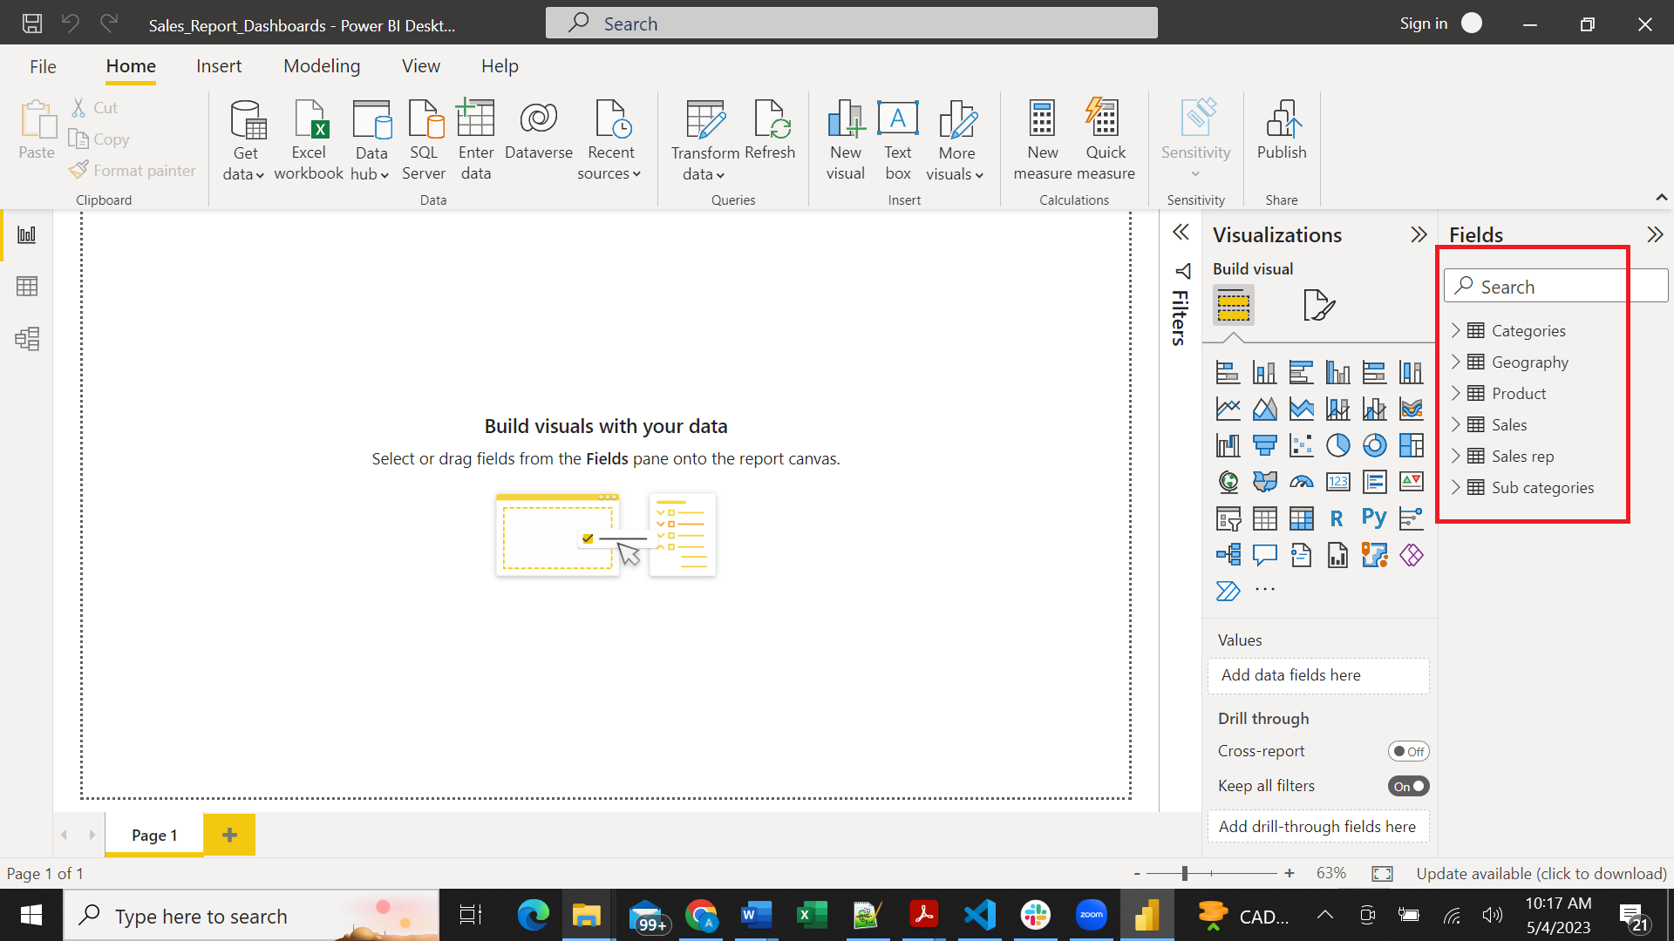

* **Step2:**